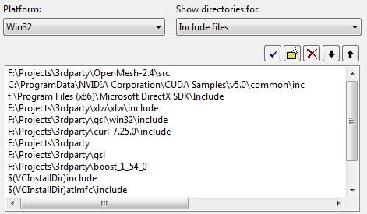

F:\Projects\3rdParty\OpenMesh-2.4\src

..

F:\Projects\3rdParty

F:\Projects\3rdParty\boost_1_54_0

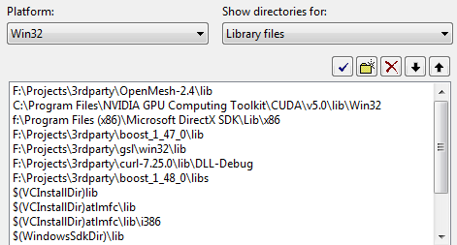

F:\Projects\3rdParty\OpenMesh-2.4\lib